No. of Pages | 3
No. of Questions | 4

Department of Computer Science and Engineering
MIDTERM EXAMINATION FALL 2011

CSE421: Computer Network
Total Marks: 60 Time Allowed: 70 minutes
- Answer ALL FIVE (5) questions
- Figure in bracket [] next to each question indicates marks for that question

Question No. 1
- Host A sends a frame destined to host B, the switch receives the frame through port 1 in figure no. 1. How does the switch decide which port to send the frame through? How will the hub act in the sending and receiving of the frame? [4 marks]
- How many collision domains are there in the scenario below in figure no. 1? [2 marks]

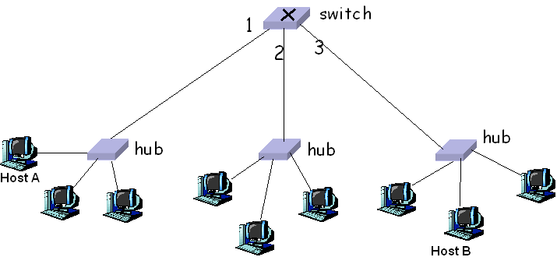
Figure no. 1

- List the steps involved in creating a checksum. [4 marks]

Question No. 2
- In the trace route command below how did the source device know trace was complete, i.e the ICMP packet has received the destination? [3 marks]
C:\ > traceroute 4.2.2.2
Tracing route to 4.2.2.2 over a maximum of 30 hops
1 1 ms 1 ms 1 ms 192.168.1.1
2 8 ms 7 ms 9 ms 10.122.208.1
3 10 ms 20 ms 12 ms 24.95.231.65
.
.
.
8 27 ms 26 ms 20 ms 4.68.103.68
9 21 ms 20 ms 24 ms 4.2.2.2
Trace complete.
Figure no. 2
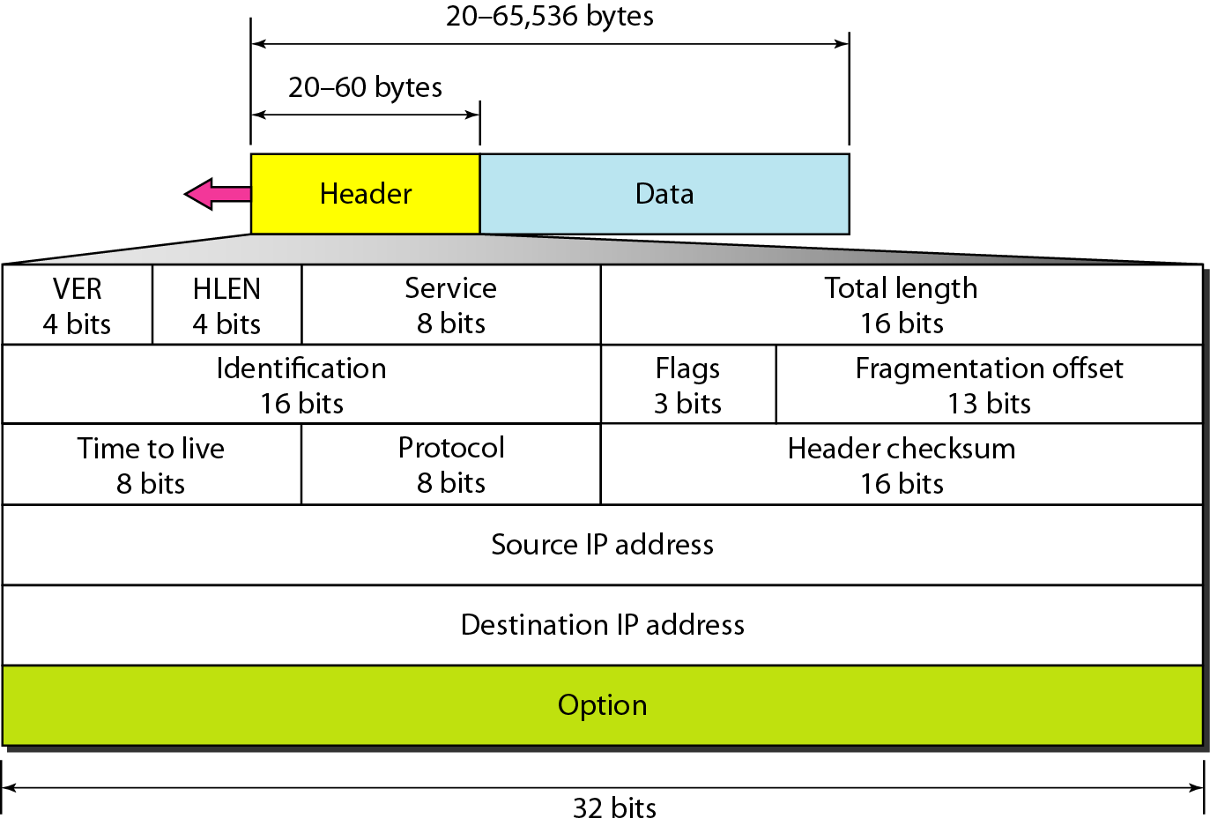
Figure no. 3
- How do the above circled fields of the IP header help in identifying a fragmented packet? Use an example to explain. A packet of 960 bytes further fragmented to handle a 500 bytes limitation. [ 4 marks]
- What is the difference of an ARP request for a host in your own network and for a host outside your own network? [3 marks]
Question 3

- Will a routing loop last forever? [2 marks]

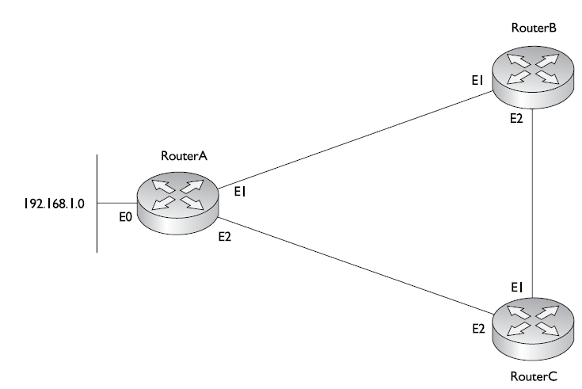
Figure no. 4
- Refer to the figure no. 4 above, the route to 192.168.1.0 of Router A goes down. What will Router A, B and C do next if they are using Route poisoning with Holddown timers in their distance vector routing? What will Router C do when it receives no updates within 180 seconds, i.e when the timer runs out? [5 marks]
- What is the difference in sending updates in Distance Vector and Link State Routing Protocol?
[3 marks]

Question 4
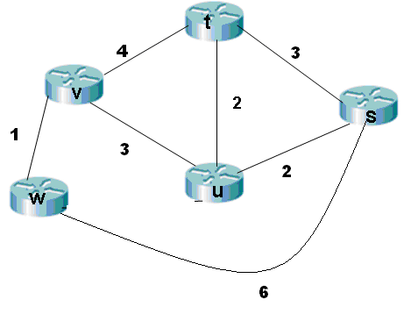
Figure no. 5
- Using Dijkstra’s algorithm, compute the shortest path from s to all other network nodes. Use the table provided seperately. [6 marks]
- What does a link state packet contain? What does each router do when link state packets have all been exchanged? [4 marks]

Question 5

- You have been given a network address 200.20.20.192/26. But you need three sub networks for your organization. Show how you can have three more subnets out of the original network address. [5 marks]
- Refer to figure below, why do the routers A,B,C,D and E have different router IDs? Why were the interface IP addresses not used in determining the Router ID? [5 marks]
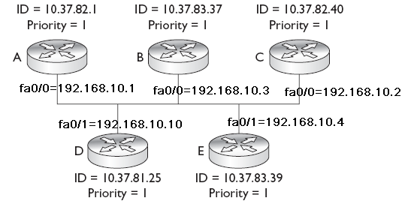
Figure no. 6

THE END

